1. | Ann’s gym charges $20 per month plus $5 per visit. Blake’s gym charges $30 per month plus $3 per visit. Ann and Blake make the same number of visits per month. How many visits would make their monthly costs equal?
 | A. 2
 | B. 5
 | C. 8
 | D. 10

2. | A line passes through the points (1, 4) and (5, 8). A second line passes through the points (2, 10) and (6, 4). At what point do the two lines intersect?
 | A. (2, 10)
 | B. (3, 6)
 | C. (4, 7)
 | D. (5, 8)

3. | A car rental company charges $34 per day for a rented car and $0.50 for every mile driven. A second car rental company charges $20 per day and $0.75 for every mile driven. What is the number of miles at which both companies charge the same amount for a one-day rental?
 | A. 56 miles
 | B. 54 miles
 | C. 36 miles
 | D. 24 miles

4. | Line K is represented by the equation y = 2x + 2. Line T goes through the points (–3, 3) and (6, 12). What is the point of intersection for lines K and T?
 | A. (1, 4)
 | B. (2, 6)
 | C. (3, 8)
 | D. (4, 10)

5. | Line J goes through the points (6, 7) and (–2, –5). Line K is represented by the equation y = x + 2. What is the point of intersection between lines J and K?
 | A. (0, –2)
 | B. (1, 2)
 | C. (2, 1)
 | D. (4, 0)

6. | Line P goes through the points (–5, –8) and (2, 13). Line Q is represented by the equation y = –2x – 8. What is the point of intersection of lines P and Q?
 | A. (–5, 2)
 | B. (–3, –2)
 | C. (1, –10)
 | D. (2, –12)

7. | Line H is graphed below. Line J passes through the points (–6, –1) and (6, 5).  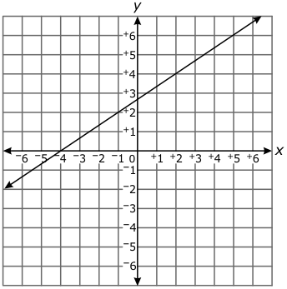  If line J is graphed on the same coordinate plane as line H, what is the point of intersection of the two lines?
 | A. (–6, –1)
 | B. (–4, 0)
 | C. (0, 2)
 | D. (4, 4)

8. | The graph of a line is shown below.  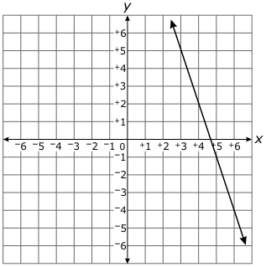  What is the x-coordinate of the point at which the line graphed above  intersects the line y = 1.25x – 3?
 | A. 2
 | B. 3
 | C. 4
 | D. 5

9. | Line Z is represented by the equation y = –6x + 4. Line Q passes through the points (–1, –8) and (2, 10). What is the point of intersection of lines Z and Q?
 | A.
 | B.
 | C. no solution
 | D. infinite solutions

10. | Line F is represented by the equation y = 2x + 1. Line G is shown on the graph below.  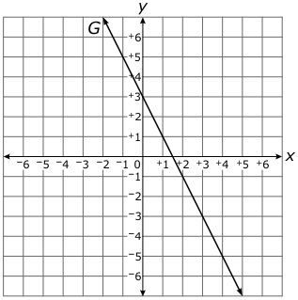  If line F is graphed on the same coordinate plane as line G, at what point would the two lines intersect?
 | A.
 | B.
 | C.
 | D.

11. | A system of equations is shown below.  y = 5x + 10  y = 10x – 5  What is the value of  x + y  ?
 | A. 25
 | B. 28
 | C. 72
 | D. 75

12. | Line f goes through the points (8, 1) and (–1, 7). Line g goes through the points (1, 3) and (–2, 3). What is the point of intersection of lines f and g?
 | A. (3, 5)
 | B. (3, 7)
 | C. (5, 3)
 | D. (7, 3)

13. | Line m is represented by the equation . Line n goes through the points (0, 4) and (–3, 4). What is the point of intersection of lines m and n?
 | A. (4, –3)
 | B. (4, –4)
 | C. (18, 3)
 | D. (18, 4)

14. | A system of equations is shown below.  y = x – 6  y = 3x + 1  What is the value of  x  in the solution to the system?
 | A. 5
 | B. 2
 | C. –2
 | D. –5

15. | Line F is graphed below. Line E, represented by the equation y = –2x – 3, will be graphed below.  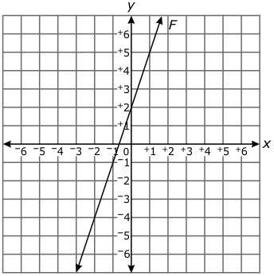  What will be the point of intersection for line E and line F?
 | A. (–1, 1)
 | B. (–1, –1)
 | C. (–2, –4)
 | D. (–4, –2)

16. | Line T is graphed below.  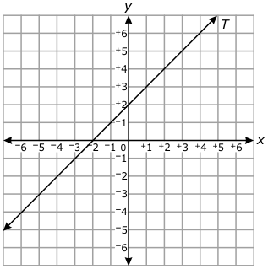  Which equation intersects line T at the point (1, 3)?
 | A. y = –2x + 4
 | B. y = –x + 4
 | C. y = x + 4
 | D. y = 2x + 4

17. | A system of equations is shown below.  y = 2x – 4  y = x + 2  What is the value of  x  in the solution to the system?
 | A. 5.6
 | B. 4.8
 | C. –4.8
 | D. –5.6

18. | Line t is graphed below.  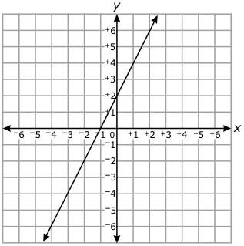  Line s goes through the points (–5, 0) and (1, 6). What is the point of intersection of lines t and s?
 | A. (0, 2)
 | B. (1, 4)
 | C. (3, 8)
 | D. (5, 10)

19. | Line N is graphed below. Line M, represented by the equation y = 3x + 6, will be graphed below.  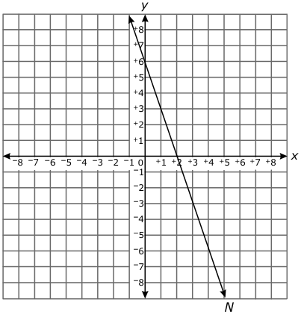  What will be the point of intersection for lines M and N?
 | A. (0, 6)
 | B. (1, 3)
 | C. (2, 0)
 | D. (3, –3)

20. | Line S goes through the points (–3, 1) and (2, 6). Line T goes through the points (0, –3) and (–2, –7). What is the point of intersection of line S and line T?
 | A. (1, –5)
 | B. (2, 3)
 | C. (6, 10)
 | D. (7, 11)

21. | LineEis represented by the equation y = 2x + 3. Line F goes through the points (–3, 2) and (3, 8). What is the point of intersection of lines E and F?
 | A. (–1, 1)
 | B. (0, 3)
 | C. (1, 5)
 | D. (2, 7)

22. | Line m is graphed below.  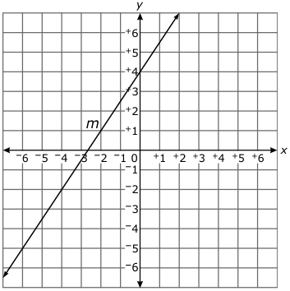  Line n is represented by the equation y = –1.5x – 2. What is the y-value of the point of intersection for the two lines?
 | A. –2
 | B. –1
 | C. 1
 | D. 2

23. | Line k goes through the points (–5, 3) and (–2, 1). Line m goes through the points (0, –3) and (2, 1). What is the point of intersection of lines k and m?
 | A. (–1, 1)
 | B. (1, –1)
 | C. (1, 0)
 | D. (2, 1)

24. | Line K passes through the points (–2, 10) and (4, –2). The equation for line M is y = 4x + 3. What is the point of intersection for lines K and M?
 | A. (0.5, 4)
 | B. (0.5, 5)
 | C. (1, 4)
 | D. (1, 5)

25. | Line p passes through points (4, 5) and (–4, –1). Line v passes through points (–2, 5) and (2, –1). What is the point of intersection of lines p and v?
 | A. (2, 0)
 | B. (0, 2)
 | C. (0, –2)
 | D. (–2, 0)

26. | Line N is represented by the equation y = x + 5. Line M is graphed below.  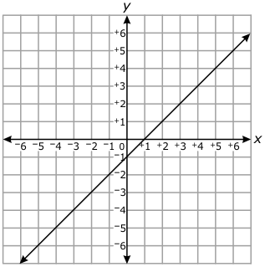  If line N is graphed on the same coordinate grid as line M, what will be the point of intersection?
 | A. (2, 1)
 | B. (2, 3)
 | C. (3, 2)
 | D. (4, 3)

27. | Line N is represented by the equation . Line M is graphed below.  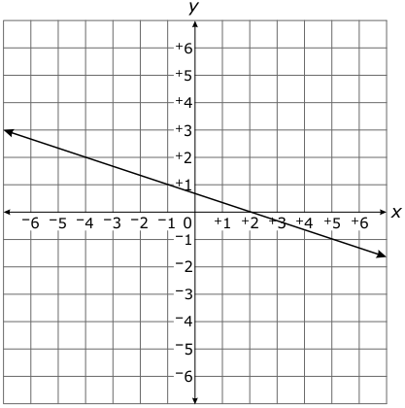  If line N is graphed on the same coordinate plane as line M, at what point will the two lines intersect?
 | A. (–4, 2)
 | B. (–2, 3)
 | C. (–1, 1)
 | D. (0, 4)

28. | A system of equations is shown below.  y = 3x – 2  y = 4x – 5  What is the  x  -value in the solution to the system?
 | A. 3
 | B. 5
 | C. 7
 | D. 10

29. | A system of equations is shown below.  y = –2x + 1  y = 4x + 7  What is the value of  x  +  y  in the solution to the system?
 | A. –4
 | B. –2
 | C. –1
 | D. 2

30. | Line g is graphed below. Line h, represented by the equation y = 3x + 10, will be graphed below.  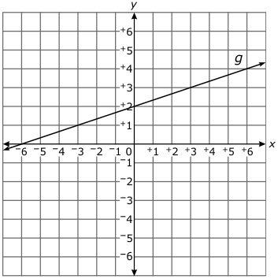  What will be the point of intersection of lines g and h?
 | A. (–6, 0)
 | B. (–3, 1)
 | C. (0, 2)
 | D. (3, 3)

31. | Line Z passes through the points (–1, 4) and (1, 12). The equation for line W is y = 2x – 6. What is the point of intersection for lines Z and W?
 | A. (0, –6)
 | B. (0, 8)
 | C. (–6, –18)
 | D. (–7, –20)

32. | Line n passes through the points (1, –4) and (4, 8). Line m is shown on the graph below.  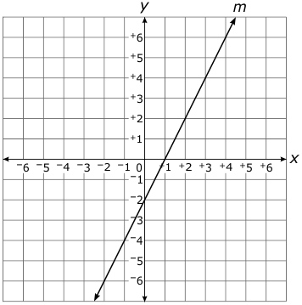  If line n is graphed on the same coordinate plane as line m, what is the point of intersection of lines m and n?
 | A. (2, 0)
 | B. (2, 2)
 | C. (3, 4)
 | D. (4, 3)

33. | Line Q is graphed below.  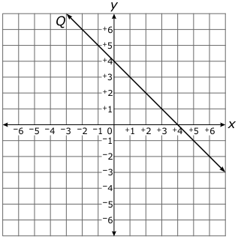  Line R passes through the points (3, 5) and (–1, 1). What is the point of intersection of lines Q and R?
 | A. (0, 4)
 | B. (1, 3)
 | C. (2, 2)
 | D. (3, 1)

34. | Line m is graphed below.  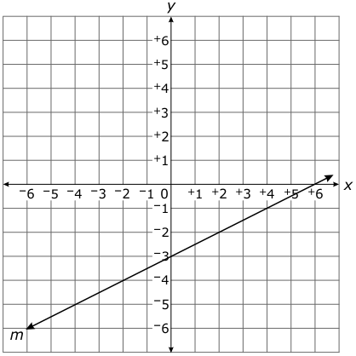  Which equation, when graphed, will intersect line m at (4, –1)?
 | A. y = 2x – 9
 | B. y = 2x – 6
 | C. y = 2x + 5
 | D. y = 2x + 6

35. | Line h is graphed below. The equation of line k is .  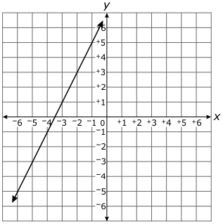  What is the point of intersection of the two lines?
 | A. (–6, –5)
 | B. (–5, –6)
 | C. (–4, –1)
 | D. (–2, 3)

36. | A line is graphed below.  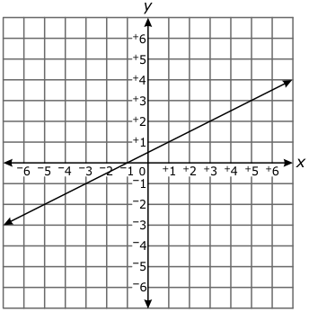  If a line represented by the equation y = 0.25x – 1 were graphed on the same coordinate plane, what would be the point of intersection?
 | A. (–6, –2.5)
 | B. (–6, –1.5)
 | C. (–2, –1.5)
 | D. (–2, –0.5)

37. | Which statement is true about the system of equations shown below?  y = 6x + 4  y = 2(3x + 2)
 | A. The solution is .
 | B. The solution is .
 | C. There is no solution.
 | D. There are infinite solutions.

38. | A system of equations is shown below.  y = 3x + 4  y = 5x + 3  Using the solution to the system, what is the value of  y  –  x  ?
 | A. 2
 | B. 3
 | C. 5
 | D. 6

39. | A system of equations is shown below.  y = –20x – 20  y = –10x + 40  What is the value of  y  in the solution to the system?
 | A. 20
 | B. 40
 | C. 60
 | D. 100

40. | A system of equations is shown below.  y = –2x + 1  y = –x – 2  What is the solution to the system?
 | A. (3, –5)
 | B. (1, –1)
 | C. (–1, 3)
 | D. (–3, 7)

41. | James paid an initial fee of $6.00 for a movie rental service. Each time he rents a movie he is charged $2.00. Sarah uses a different movie rental service that charges based on the equation y = 3x + 4, where y is the total cost and x is the number of movies rented. At what point are the prices of the two services the same?
 | A. (0.6, 0.6)
 | B. (0.6, 6)
 | C. (2, 10)
 | D. (10, 2)

42. | A system of equations is shown below.  What is the value of  x  that makes the system of equations true?
 | A. x = –2
 | B. x = –0.4
 | C. x = 1.7
 | D. x = 2

43. | What is the solution to the system of equations below?
 | A. (2, 3)
 | B. (2, 4)
 | C. (3, 2)
 | D. (3, 5)

44. | A line is graphed below.  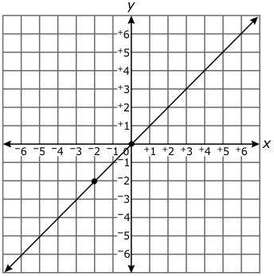  Which equation would intersect the line on the graph at the point (–2, –2)?
 | A. y = 3x + 4
 | B. y = 2x – 6
 | C. y = –x + 4
 | D. y = –3x – 4

45. | Line w goes through the points (1, 3) and (–2, –3). Line z goes through the points (–4, 0) and (2, –2). What is the point of intersection of lines w and z?
 | A. (0, 1)
 | B. (0, –1)
 | C. (–1, –1)
 | D. (–2, –1)

46. | Line g is on the graph below. Line h, represented by the equation , will be graphed below.  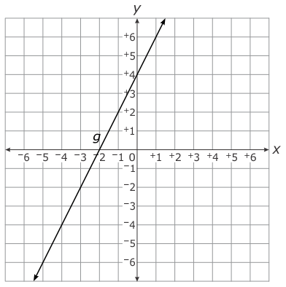  What will be the point of intersection of lines  g  and  h  ?
 | A. (–3, –2)
 | B. (–2, –3)
 | C. (2, –3)
 | D. (3, –2)

47. | Line s goes through the points (–2, –6) and (4, 2). Line t goes through the points (–2, 4) and (4, –8). What is the point of intersection of lines s and t?
 | A. (2, –1)
 | B. (1, –2)
 | C. (–1, 2)
 | D. (–2, 1)

48. | A system of equations is shown below.  y = 2x – 1  y = 3x – 5  What is the  y  -value in the solution to the system?
 | A. –13
 | B. –6
 | C. 4
 | D. 7

49. | A system of equations is shown below.  y = 2x + 1  y = x + 2  What is the solution to the system?
 | A. (0, 1)
 | B. (1, 2)
 | C. (1, 3)
 | D. (2, 4)

50. | A system of equations is shown below.  y = –4  y = x + 4  What is the solution to the system?
 | A. (–8, –4)
 | B. (8, 4)
 | C. (–4, 0)
 | D. (–4, –4)

51. | A system of equations is shown below.  What is the  x  -value in the solution to the system?
 | A. –4
 | B. –3
 | C. –2
 | D. –1

52. | A system of equations is shown below.  y = 4x  y = x – 6  What is the  x-  value in the solution to the system?
 | A. –8
 | B. –2
 | C. 2
 | D. 8

53. | Line j goes through the points (–1, 2) and (2, –1). Line k goes through the points (5, 2) and (4, 0). What is the point of intersection for line j and line k?
 | A. (2, –1)
 | B. (3, –2)
 | C. (4, 0)
 | D. (6, –5)

54. | Which ordered pair would be the point of intersection of the graph below and y = x + 1?  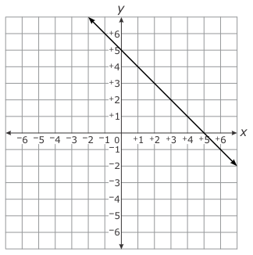
 | A. (0, 5)
 | B. (1, 4)
 | C. (2, 3)
 | D. (3, 4)

55. | The line of the equation y = –4x – 5 will be graphed on the coordinate plane, intersecting the line below.  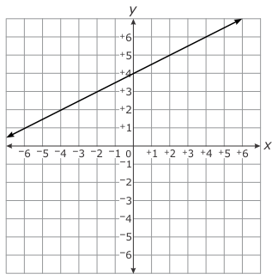  What will be the point of intersection of the two lines?
 | A. (0, 4)
 | B. (0, –5)
 | C. (–2, 3)
 | D. (3, –2)

56. | A system of equations is shown below.  What is the solution to the system?
 | A. (2, 3)
 | B. (3, 2)
 | C. (5, 6)
 | D. (6, 5)

57. | Which equation intersects the line graphed below when x = 1?  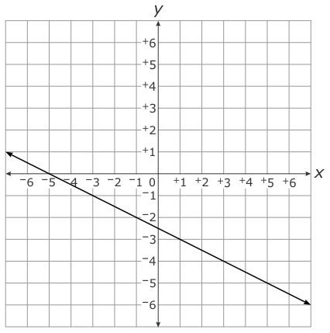
 | A. y = –x – 4
 | B. y = –x + 4
 | C. y = x – 4
 | D. y = x + 4

58. | Line p passes through the points (–4, –2) and (0, 0). Line r passes through the points (–1, –8) and (2, –2). What is the point of intersection of lines p and r?
 | A. (1, 4)
 | B. (3, 0)
 | C. (3, 1)
 | D. (4, 2)

59. | A system of equations is shown below.  y = x – 7  y = x – 5  What is the solution to the system of equations?
 | A. (–11, –3)
 | B. (–1, 8)
 | C. (6, –2)
 | D. (8, –1)

60. | A system of equations is shown below.  y = 3x – 6  y = 2x + 2  What is the solution to the system of equations?
 | A. (–8, –14)
 | B. (–4, –6)
 | C. (4, 6)
 | D. (8, 18)

61. | Which graph shows a system of equations that has a solution of (4, 1)?
 | A.
 | B.
 | C.
 | D.

62. | Line F goes through the points (0, 6) and (6, –3). Line G is graphed below.  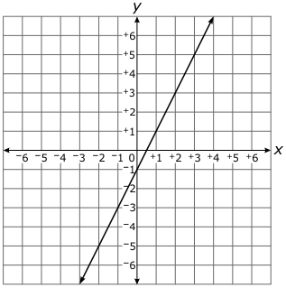  If line F is graphed on the same coordinate plane as line G, at what point will the two lines intersect?
 | A. (1, 2)
 | B. (2, 1)
 | C. (2, 3)
 | D. (3, 2)

63. | A line is graphed below.  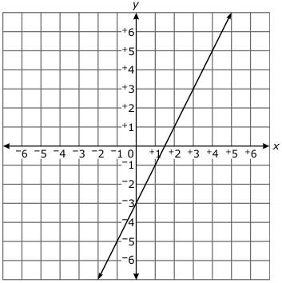  If a line that goes through the points (4, –5) and (7, –14) is graphed above, at what point will the two lines intersect?
 | A. (–2, –7)
 | B. (0, –3)
 | C. (1, –1)
 | D. (2, 1)

64. | Line s is represented by the equation y = –x + 3. Line t goes through the points (5, 1) and (3, –3). What is the point of intersection for lines s and t?
 | A. (0, 3)
 | B. (3, –3)
 | C. (4, –1)
 | D. (3, 0)

65. | A system of equations is shown below.  y = x + 11  y = x + 13  What is the solution to the system of equations?
 | A. (–8, 7)
 | B. (–2, 10)
 | C. (4, 16)
 | D. (8, 15)

66. | A system of equations is shown below.  What is the  x  -value of the solution to the system of equations?
 | A.
 | B.
 | C.
 | D.

67. | A system of equations is shown below.  What is the solution to the system of equations?
 | A. infinite solutions
 | B. no solution
 | C. (6, –9)
 | D. (–9, 6)

68. | The tickets to a high school hockey game cost either $6 or $11. A total of 450 tickets, worth $3,950, were sold. How much of the $3,950 was made from selling the $6 tickets?
 | A. $2,750
 | B. $1,200
 | C. $250
 | D. $200

69. | What is the y-value of the solution to the system of equations shown below?  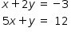
 | A.
 | B.
 | C.
 | D.

70. | If the system of equations represented by and has no solution, what must be true of these equations?
 | A.
 | B.
 | C.
 | D.

71. | Which statement is correct for the pair of linear equations shown below?  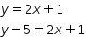
 | A. The equations intersect at because y is equal to
 | B. The equations intersect at or 5 because y is equal to
 | C. The equations represent the same line because is always equal to
 | D. The equations represent parallel lines because cannot be equal to both y and

